Creative Performance

SHEENA LC WALKER BA CONFERENCE KEYNOTE SPEAKER BY DESIGN
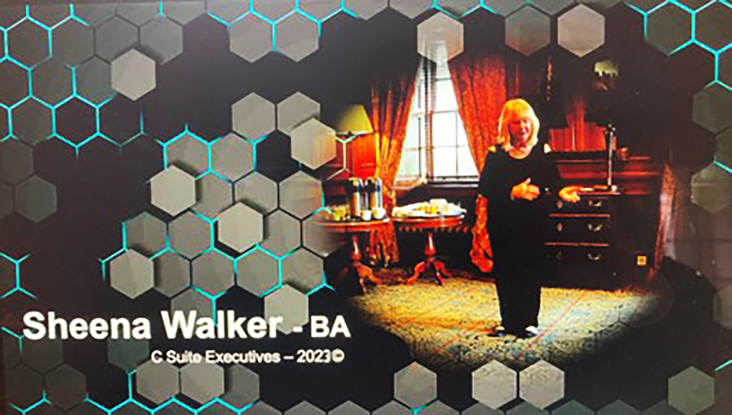

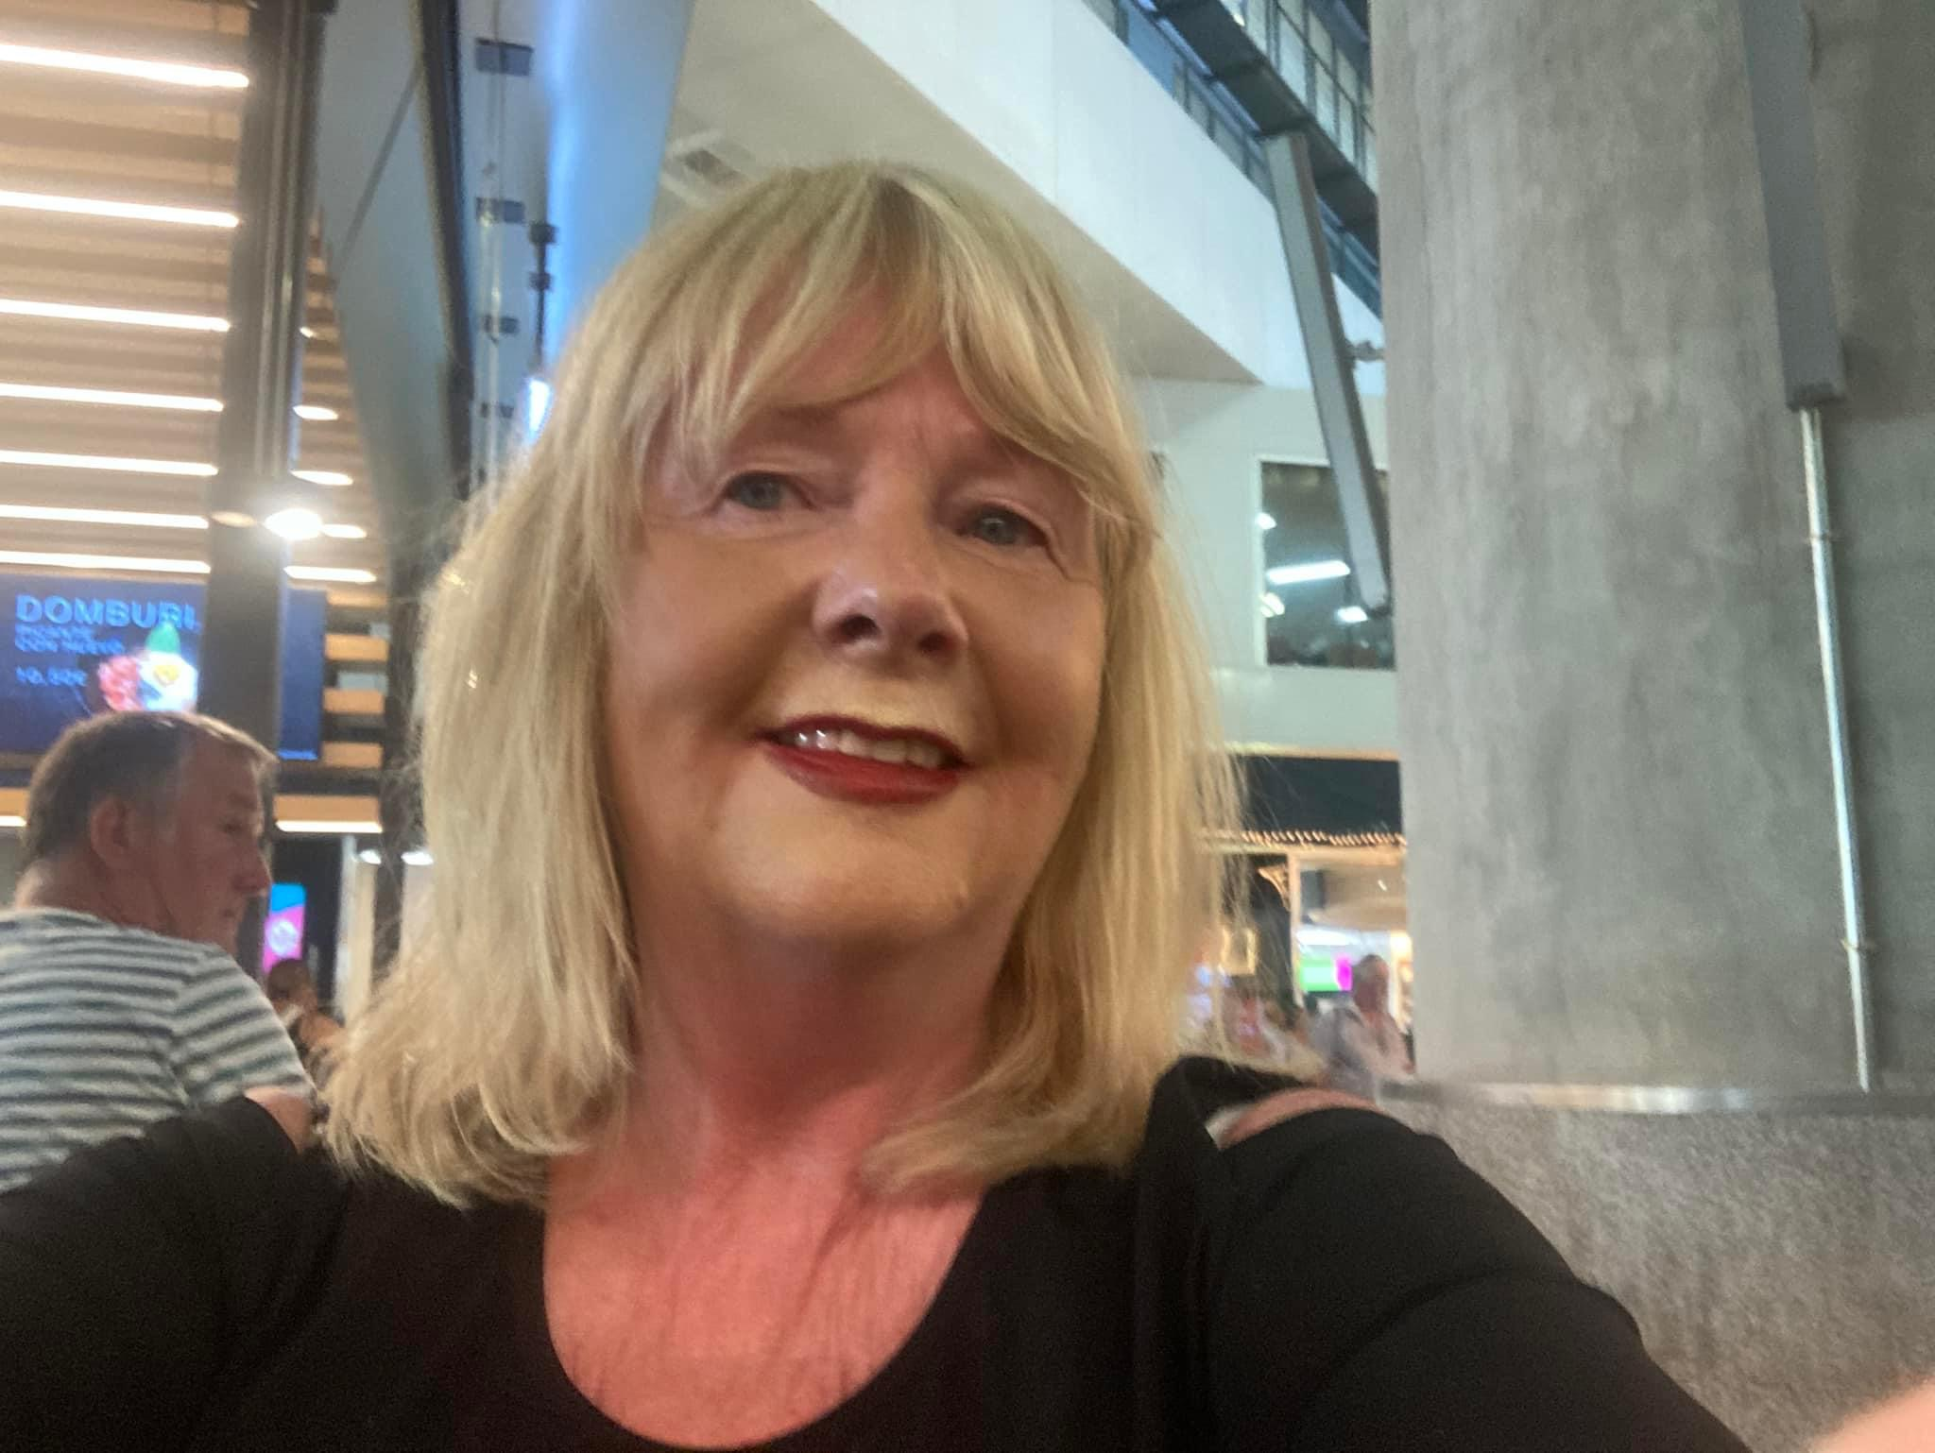
Would you like a dynamic speaker to MC your conference?

Would you like to have a powerful persuasive charismatic engaging presenter?

Do you engage speakers that have the WOW factor and an innovative unique approach to corporate learning?

Sheena LC Walker
is a Professional Speaker, Radio presenter. Author, Executive Trainer TEDx Coach and International Business Growth expert.

Sheena turns experts into an authority, inspires executives, entrepreneurs, speakers and trainers to create world-class programmes and presentations. She does this faster and more effectively than any other speaker or coach.
Best clients are individuals and companies who realise those powerful, persuasive & professional presentations will give them a competitive edge.
Your Presenter Sheena Walker is not only a Certified Speaking Professional but is also a graduate of the University of Stirling. Sheena is the founder of Performance by Design and has been speaking professionally for 20 years, so you can be assured you are learning from someone who is a true expert in business and behavioural change.
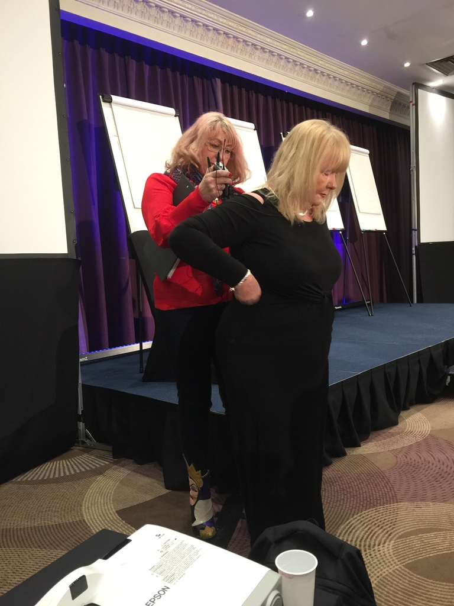

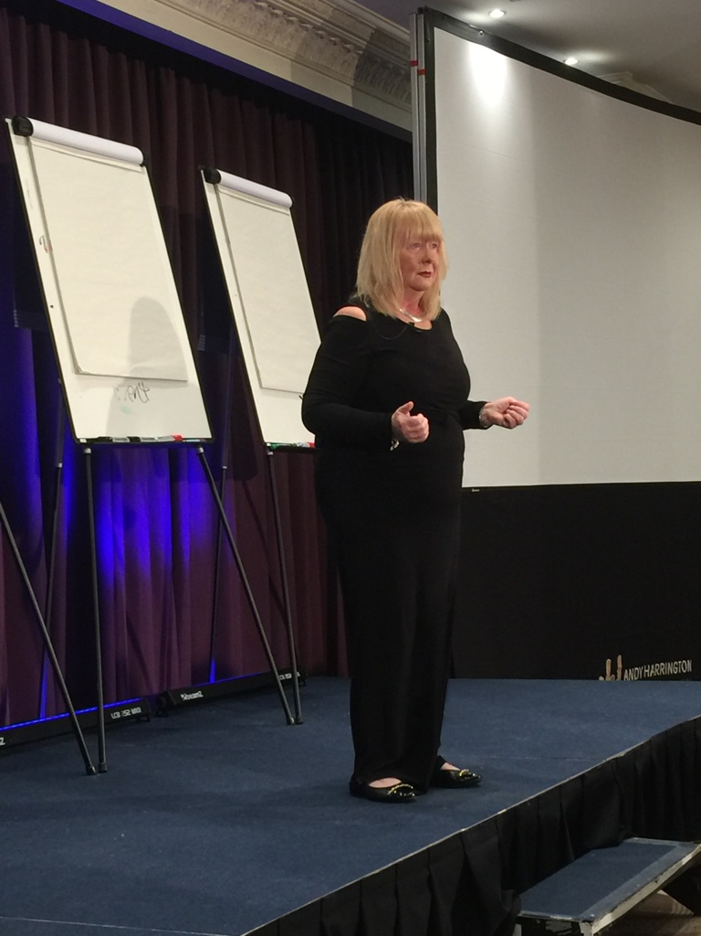
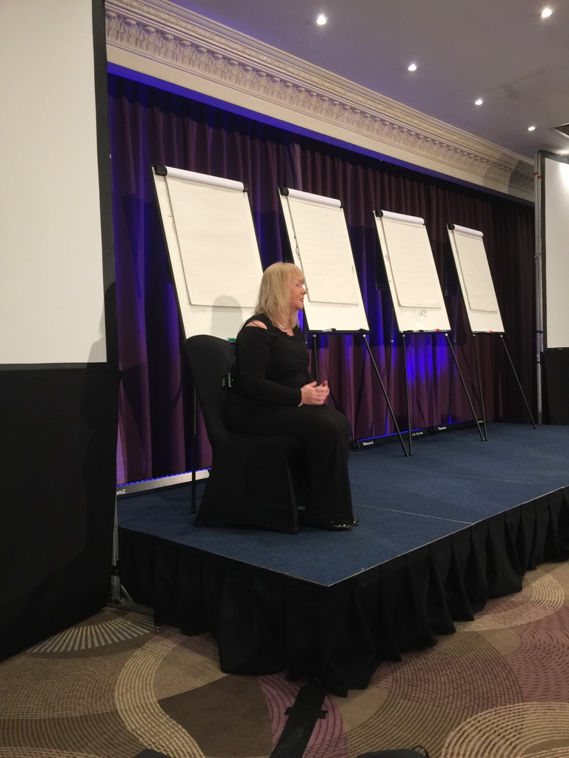

Looking for a Powerful Keynote Speaker for Your Next Conference
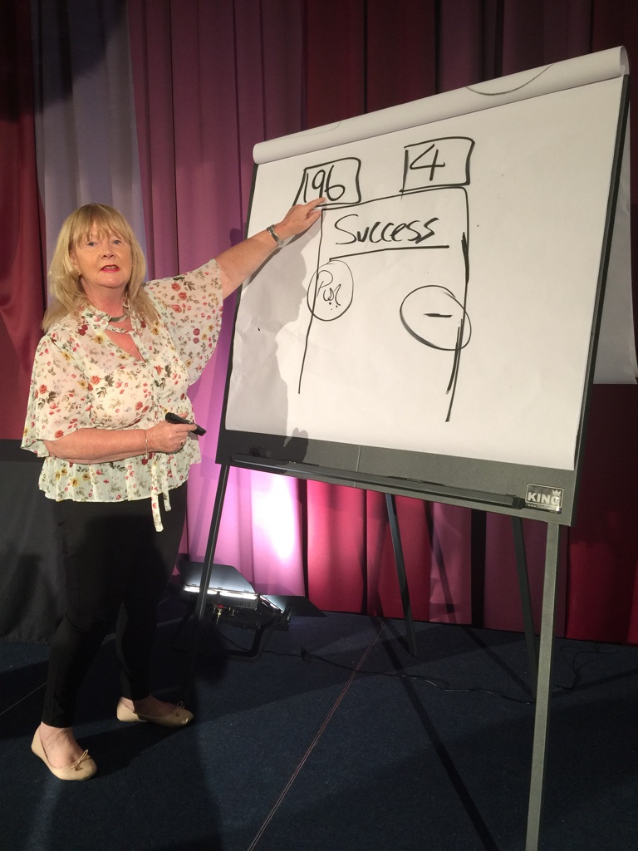

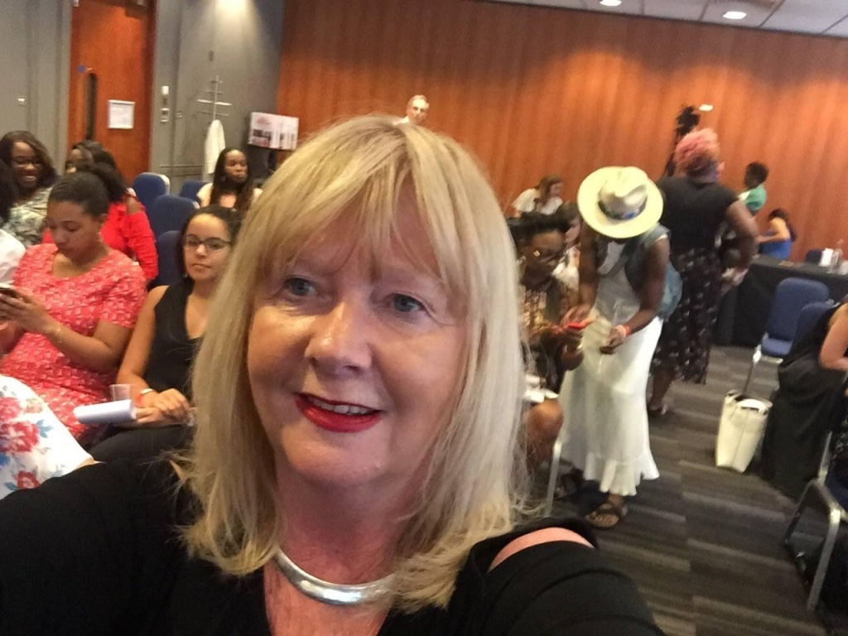
A Keynote Speaker for your corporate event. An Inspiring speaker for in-house talks and team building days.
Discover how building a team creates extraordinary results. We offer Mastery with a difference to give you the winning edge. Discover how Mini by Design Master classes will position your conference.

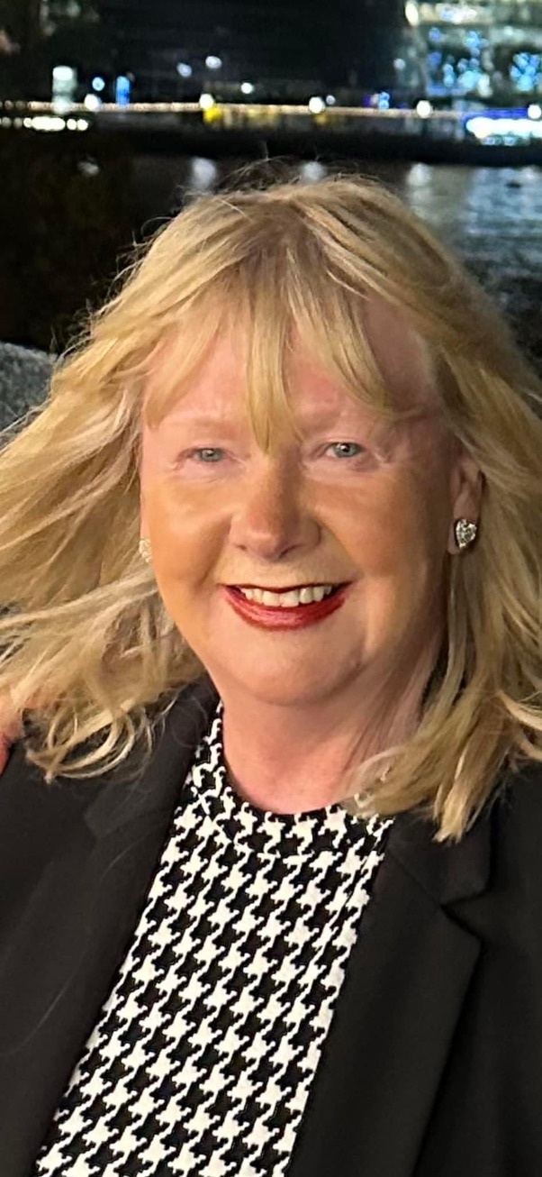

Unique Signature model
Sheena’s Signature model is the Inspiration behind her keynote success, which address 7 key areas of performance improvement leading to extraordinary results.

Keynotes By Design

- Performance BY Design Thinking
- The Science of a Corporate Athlete
- Winning Results Beyond the Arena

Working with You to Lead the Event Industry
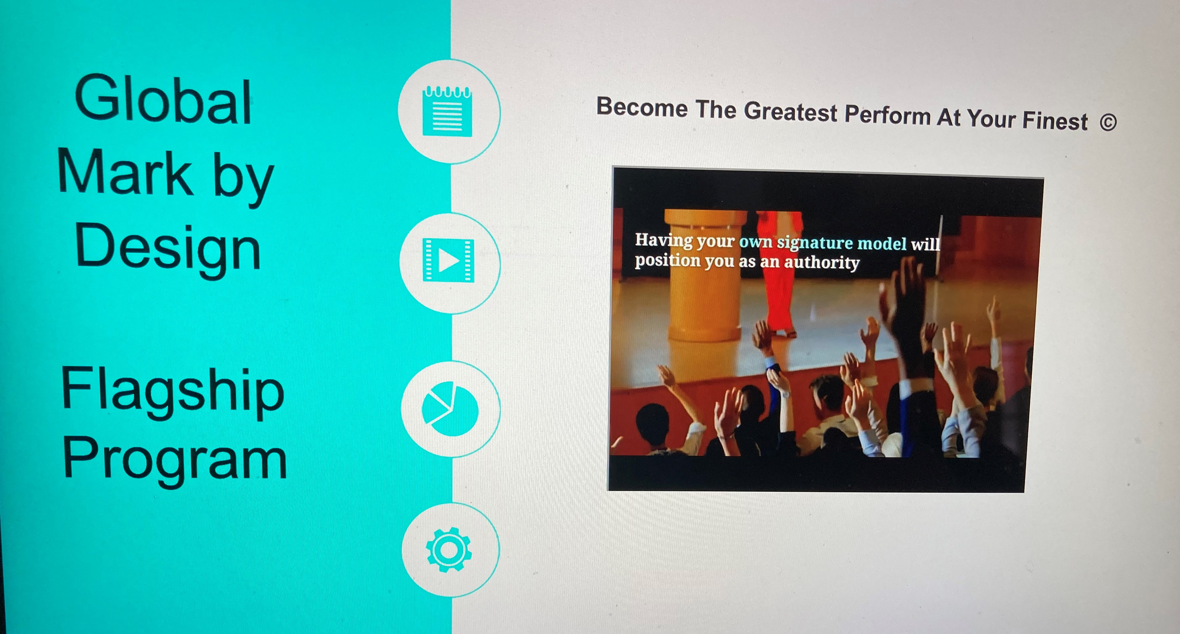
- Do you use professional inspirational speakers?
- Who have you used in the past?
- How are decisions made for conference speakers?
- When do you begin planning your events?
- Do your speakers assist you in planning the event?
- Do you focus on speakers who get results?
- Do you have speakers who deal with the unexpected?
- Do your speakers have an innovative unique approach to learning?
- How often do you change your company positioning to future clients?
- Is there anything else you need from me in order to decide if I would be a good fit for your company?
Contact us: We don't do average. We will make you outstanding at what you do.
We are delighted to work with some terrific organizations. It goes without saying we would love to work with you to.
Contact Sheena for Global mark Speaker Conferences throughout the world.
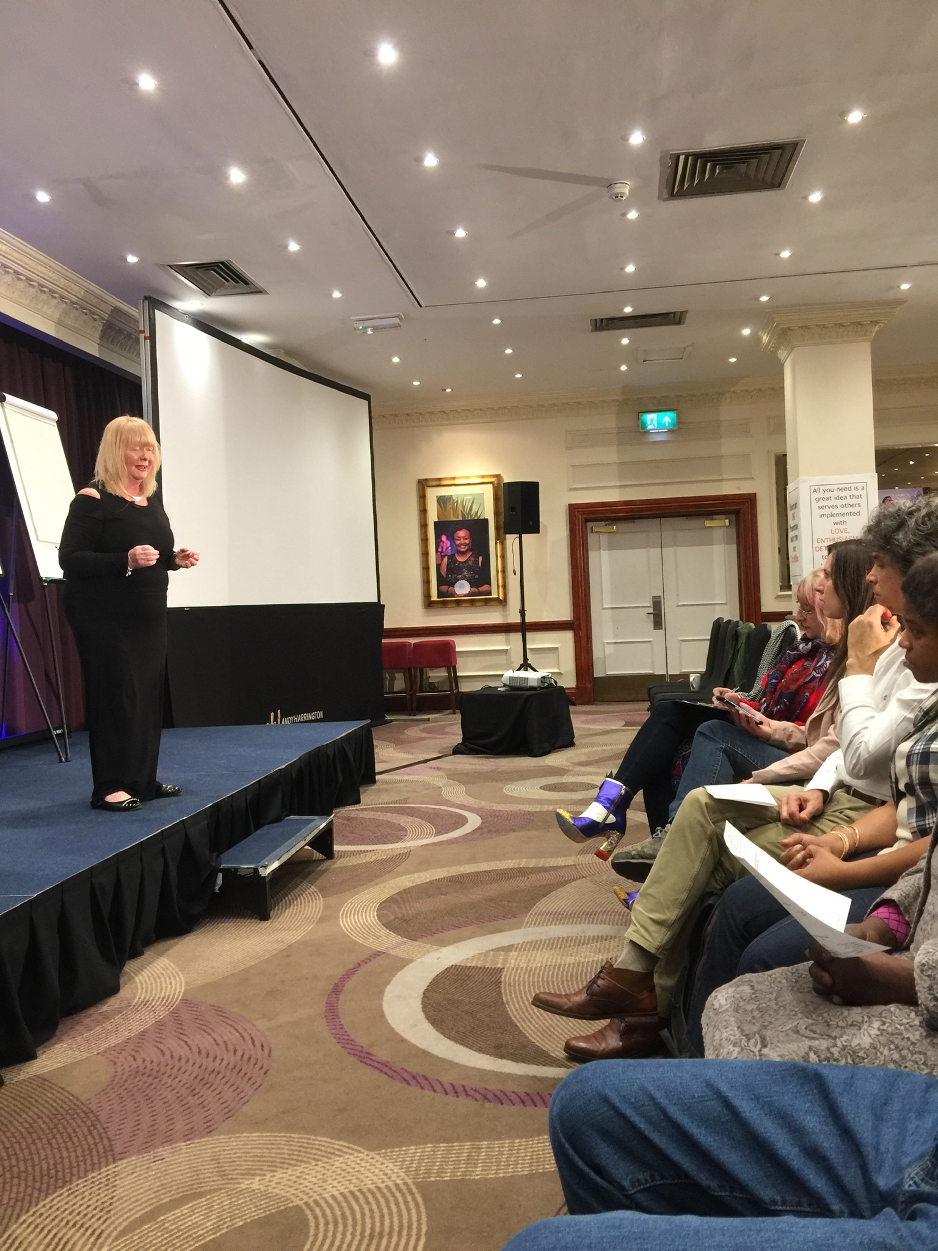

Performance By DESIGN THINKING

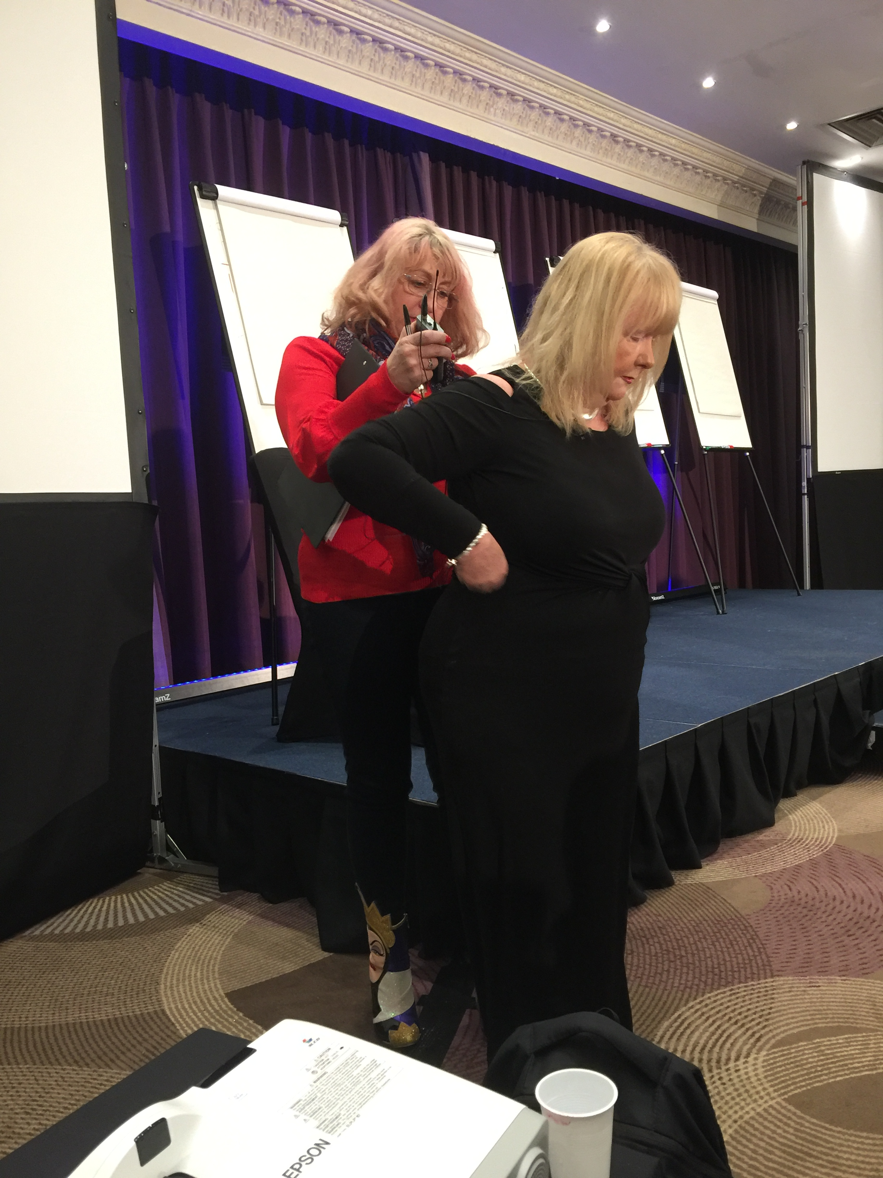
Sheena speaks on Performance Mastery, Laser Leadership and Performance Design. Her focus is to help you achieve YOUR goal from your event, so she will customise her talk based on your event’s particular needs.
Here are her most requested topics. Please bear in mind that she can deliver these either as Keynotes or as a Masterclass in your organisation. Whatever will have the biggest impact for you?

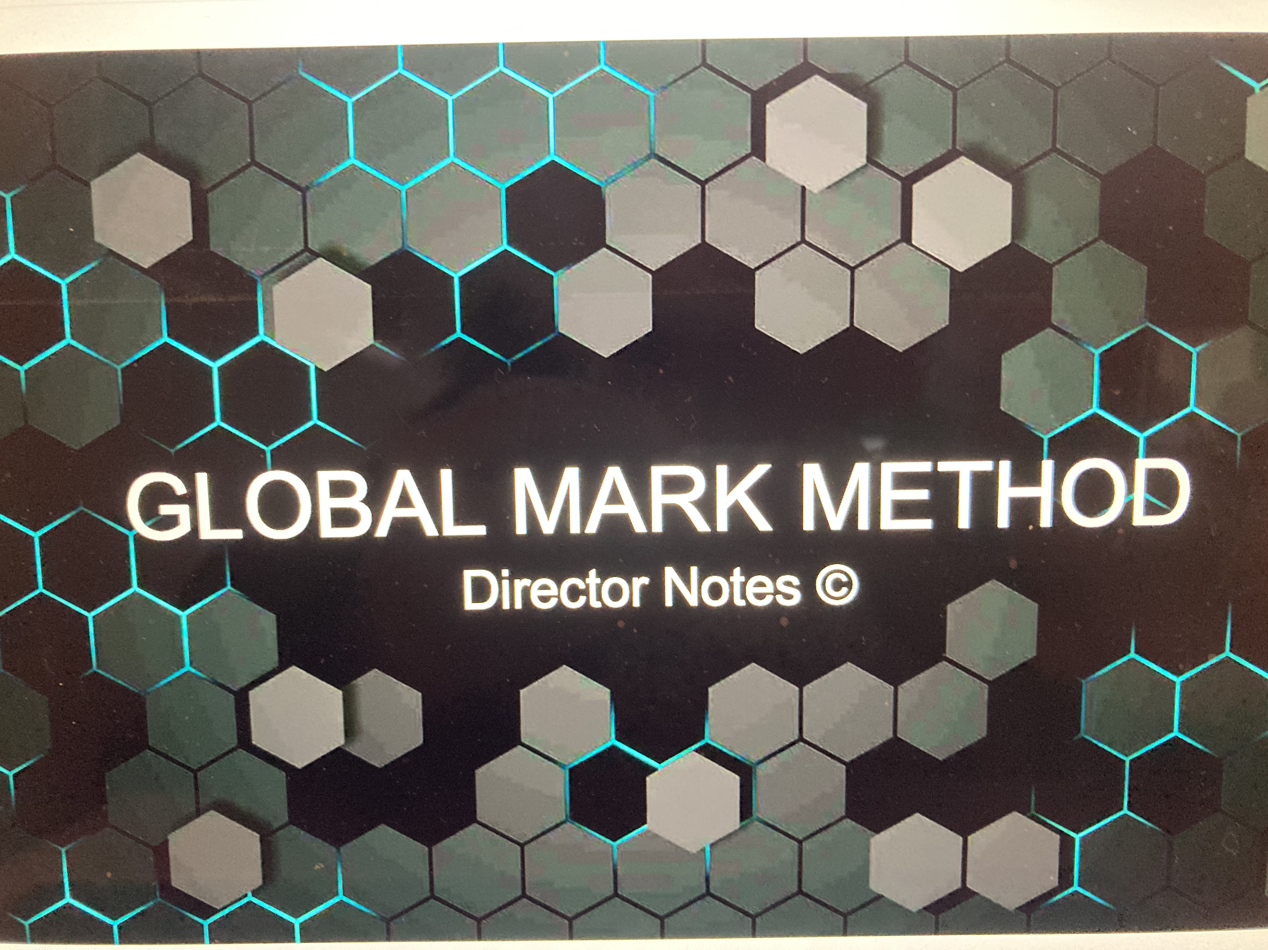
Performance By Design Thinking ©
How to have an “Individual Centred” Approach in your Organisation.
Have you noticed the world is changing? Creativity was once considered the preserve of a select few, an inspired elite, those working in the “creative industries”. Now you can take that new idea to be commercially viable.
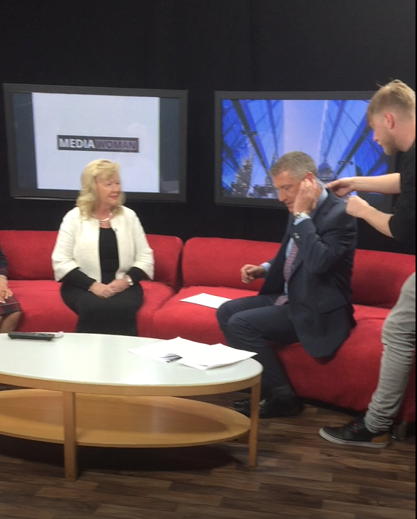
Discover how “Designing Thinking” will make you different, we believe that not only can entrepreneurs can come up with new creative ideas, but you can learn to be and think differently. Perhaps you have limited resources and planning skills but you may have a brilliant idea for that new product or service Achieve key results fast and become commercially viable and different, Sheena will share how.

THe DNA Of A CORPORATE Athlete ©
Breaking Performance Boundaries in Your Organisation
Getting the results that take you to the top of your game are among the top goals of any business professional. How are these results created? What is it about elite performers that differ from the average person?
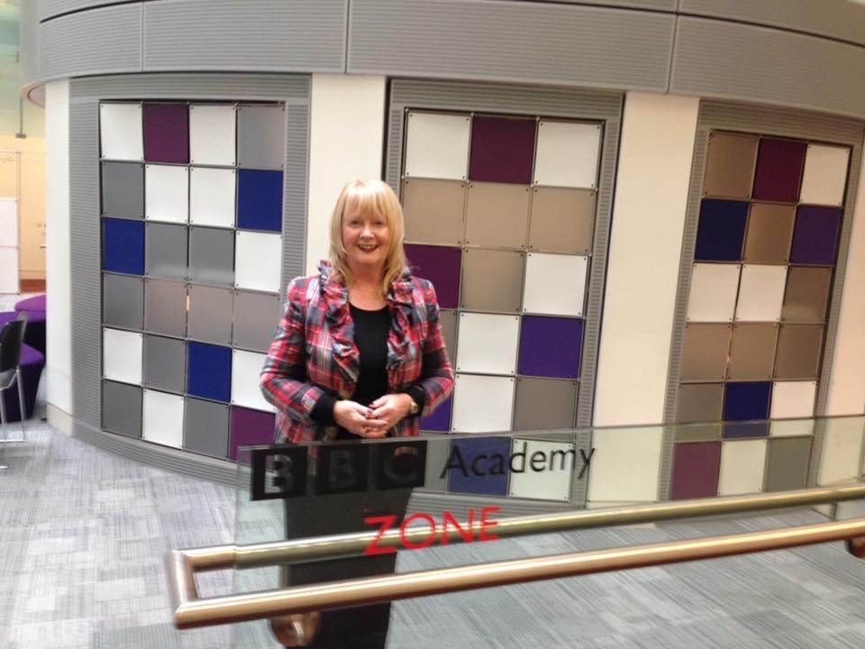
The secret lies with the critical success factors, every game has a hero but behind each great celebration lies hours of planning and extensive training, and true absolute determination to be at that optimal performance level to become a Corporate Athlete.
Sheena has this passion for performance and has discovered the formula for Olympic Winning Strategies. She will help you apply this formula to your career, your business and your team using the sporting methodology, Sheena can share the science that will take your organisation to the next level, keeping you ahead of the competition.

WINNING RESULTS BEYOND THE ARENA©
When Performance Arrives, Preparation Has Gone
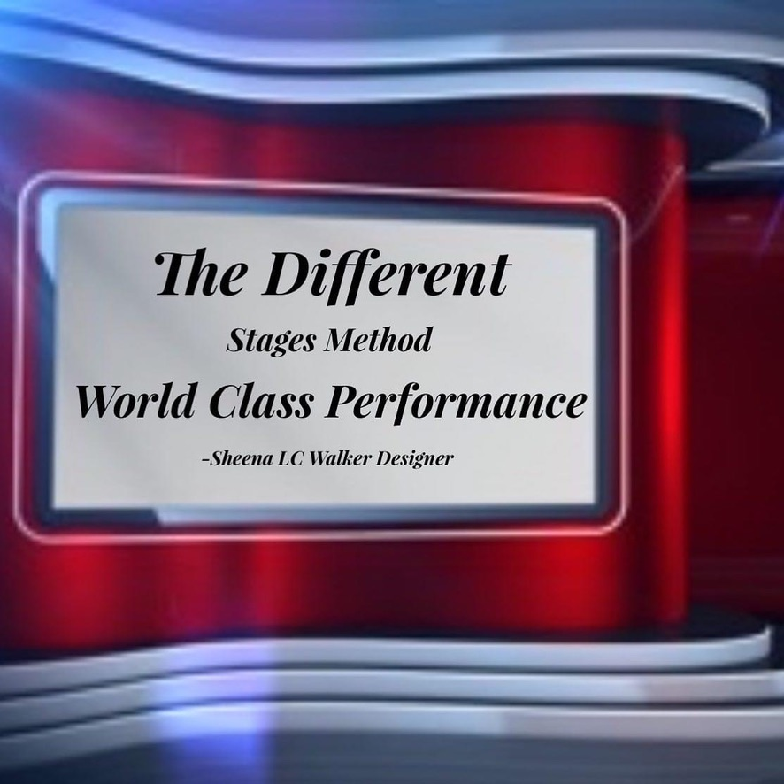
As an Influential Leader, how do you describe your ability to tackle tough situations? Dealing with the demands of the role includes maintaining a state of psychological preparedness.
My 9 Principles of Habitual Excellence learned through my experience working with elite athletes and that of high-performance sport capture winning beyond the arena. This applies equally to sport and your professional life this will help you adjust with new situations in your unique game. Learning to bounce back and to not let obstacles stop you is the first step towards success. Obsessed with the habits and processes of top performers, Sheena will influence you to adopt these principles that instill energy, passion and confidence to your team. Earning the respect of those you lead will make you stand out as an Influential Successful Leader - Successful Leaders are those with Successful daily habits.

Global Masterclasses for Executives
The Performance by Design Master Class is one of Sheena's Signature programs based on her Powerful Presentation Principles. The Masterclass is designed to be highly interactive combining both The Art and Science of Powerful Presenting delivered by one of the most highly qualified, experienced, and engaging presenters you will find. Sheena works as an International Growth Speaker and Executive Speech Coach across the globe.
The Performance by Design one day or a two-day program can also be presented in-house for your organization.
You will leave the masterclass with the knowledge and skills to be able to engage your audience and get your intended message across and be positioned as an authority.
Investment in this program
Contact me for details on the investment to this program.
In-house price also available on application.
Testimonial
I attended one of Sheena's Masterclasses I was blown away! She is sharp, to the point and creative. Just a genius at helping you to script your keynote.
There are many presentation skills workshops out there, but this was by far the most professional and inspiring workshop I have attended in years. She had everyone mesmerized by her expertise.
Web site- www.sheenawalker.com

Video: Flagship Program

https://youtu.be/Isiz5wua4DM





The Market Place Always rewards Mastery.
My Gift to you?
Speaking Is The Most Profitable Skill In Business
Download the attached e books:
Steps to Become a Stellar Presenter
https://bit.ly/3SGMXm8

24 Celebrity Speaking Tips
https://bit.ly/3Wwnb5W

Book a Design Call
https://www.sheenawalker.com/book/
About Sheena
https://card.pramaze.com/sheena-walker

Copyright Sheena Walker ©



